Chinese test 16 format and instructions. It will be tested on 5/5 (Thursday).
姓名：____________________ _______月 ________ 日 星期_______________
(I will help all students to do name and date)

Matching the pictures and characters
(I will read the characters to them and also no English when do the test.)

1. 粉红色(pink) 2. 说(say) 3. 没有(do not have, no) 4.看书(read book)
5. 为什么(why) 6. 葡萄(grape) 7. 老师(teacher) 8. 外面(outside)
9. 下课(recess) 10. 汽水(soda) 11. 下雪(snowing) 12. 上面(up)
13. 黄色(yellow)

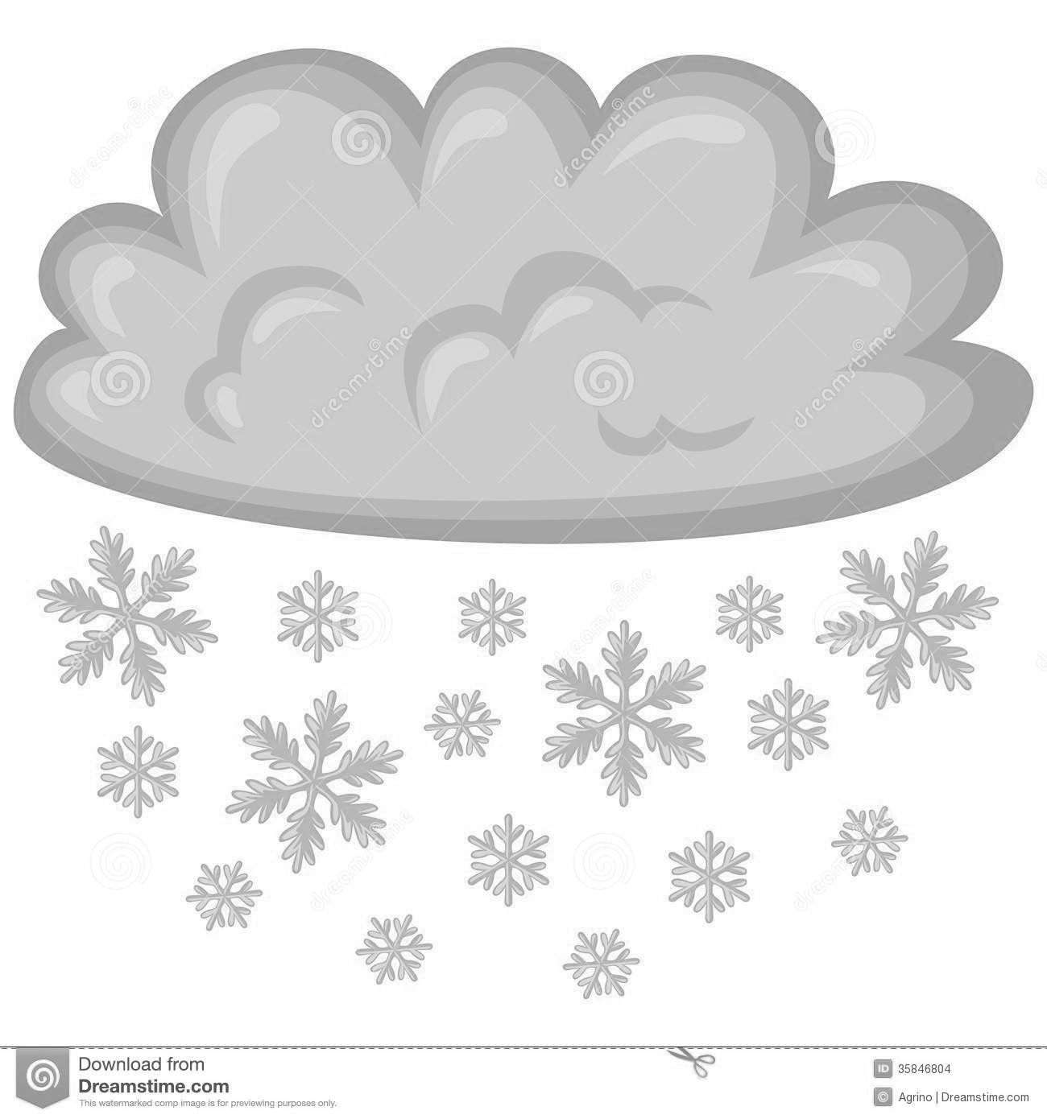
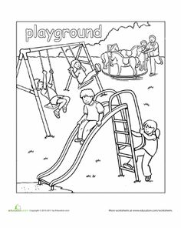
Circle what the teacher say: Multiple chocie
13
1
12
11
10
9
8
7
6
4
5
3
2
1. (1) 没有 (do not have) (2) 雪(snow) (3) 玩(play)

2. (1) 玩雪(play snow) (2) 要不要(want or don’t want)
(3) 外面(outside)

3. (1) 你们(you all) (2) 老人(old people) (3) 走一走(walk)

4. (1) 老师(teacher) (2) 课(lesson, class) (3) 雪山(snow mountain)

Filling in the blank: 说(say) 没有(do not have)
要(want) 老师 (teacher)

- chen __老 师__ __说__ 你们一起玩雪 。
Ms. Chen says that you all play snow together.

- Nancy__没有__在Ridgecrest 小学。
Nancy is not at Ridgecrest elementary school.

3. 你__要___不要上厕所？Do you want to go to restroom?

Assignments:

Recording: Clothes and colors, Due 5/10
http://firstgradedi.weebly.com/chinese-recording-assignments.html

Math Packet:
- Deadline 5/2- Topic 12
- Deadline 5/3- Topic 13
- Deadline 5/4- Topic 14
- Deadline 5/5- Topic 15

You can turn in a packet or page by page.

Science
The weather condition

This week the oral language topic:
Lesson: What animal’s _____ long?
https://quizlet.com/120657713/flashcards
Mandrain Matrix: I don’t want to go to school.
http://firstgradedi.weebly.com/mandarin-matrix.html

Reading:
High Frequency vocabulary 76-100: (Quizlet) https://quizlet.com/97609461/highfrequency-vocabulary-1st-grade-chinese-flash-cards/

Chinese Book: There is no book sent home anymore. But we watch the video on http://firstgradedi.weebly.com/chinese-baggy-book.html

Hide and Seek.
(4/24-5/01)

Topic 14: shapes
Review: Topic 13, Time
o’clock 点钟 ____:30 ____点半
time 时间 parallelogram 平行四边形
square 正方形 trapezoid 梯形
rectangle 长方形 Circle 圆形
triangle 三角形
These vocabulary can be found on bloghttps://quizlet.com/98183656/flashcards

Notes to Parents:
I attached vocabulary from Mandarin Matrix for this year again. You can practice with kids to prepare the test –YCT, it is a end-of-year test for all Chinese program 1st and 2nd grade students. I will review some questions with students at school, too. We are still waiting for information about testing dates. Please let me know if you have any questions. Enjoy the weekend disappear9541@gmail.com Hsiaomei.tsai@canyonsdistrict.org

Chinese

Ms. Tsai

Math

