Chinese test 15 format and instructions. It will be tested on 4/28 (Thursday).

姓名：____________________ _______月 ________ 日 星期_______________
(I will help all students to do name and date)

Matching the pictures and characters
(I will read the characters to them and also no English when do the test.)

看书(read book) 老师(teacher) 橙色(orange) 上面(up) 葡萄(grape) 汽水(soda) 为什么(why) 黄色(yellow) 要(want) 跟我玩(play with me)
他(he) 她(she) 下课(recess)
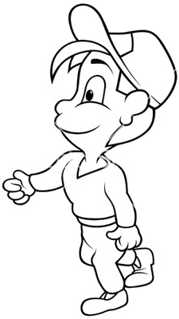
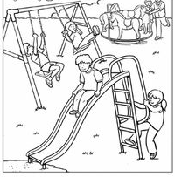
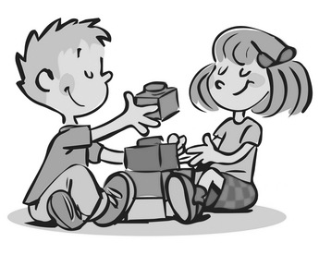
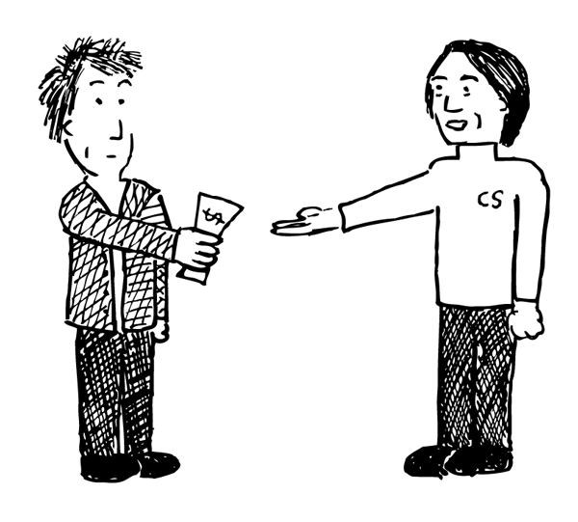
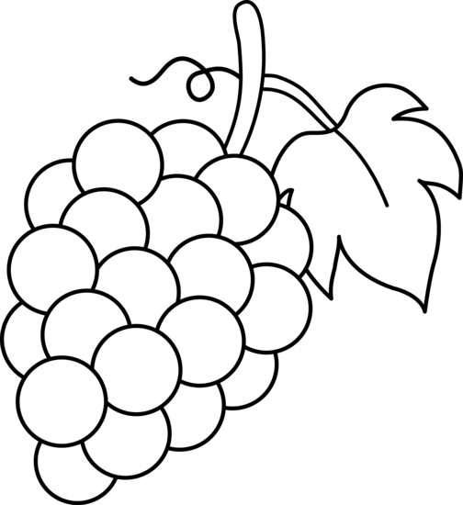

Circle what the teacher say: Multiple chocie
1. (1) 吃面 (eat noodles) (2) 看(see, look) (3) 玩(play)

2. (1) 要不要(want or don’t want) (2) 不要(don’t want)
(3) 跟朋友玩 (play with friends)

3. (1) 走一走(walk) (2) 老人(old people) (3) 小羊(sheep)

4. (1) 老师(teacher) (2) 课(lesson, class) (3) 为什么(why)

Filling in the blank: 为什么(why) 跟(with) 要(want)
老师 (teacher)

- 我_跟__Campo __老 师__一起看书。
I read books with Ms. Campo together.

- __为什么___Nancy不在这里？
why Nancy is not here?

- 你妈妈__要___喝果汁吗？
Does your mom want to drink juice?

Chinese Recording assignment:

Topic: What clothes do you

like to wear?
http://firstgradedi.weebly.com/chinese-recording-assignments.html

This week the oral language topic:
Lesson: What animal’s _____ long?
https://quizlet.com/120657713/flashcards
Mandrain Matrix: I don’t want to go to school.
http://firstgradedi.weebly.com/mandarin-matrix.html

Reading:
High Frequency vocabulary 76-100: (Quizlet) https://quizlet.com/97609461/highfrequency-vocabulary-1st-grade-chinese-flash-cards/

Chinese Book: There is no book sent home anymore. But we watch the video on http://firstgradedi.weebly.com/chinese-baggy-book.html.
Hide and Seek.
(4/24-5/01)

Topic 14: shapes
Review: Topic 13, Time
o’clock 点钟 ____:30 ____点半
time 时间 parallelogram 平行四边形
square 正方形 trapezoid 梯形
rectangle 长方形 Circle 圆形
triangle 三角形
These vocabulary can be found on bloghttps://quizlet.com/98183656/flashcards

Math homework for spring break:
No math homework.
There is only a packet of Chinese writing homework.

Notes to Parents:
I attached vocabulary from Mandarin Matrix for this year. You can practice with kids to prepare the test –YCT, it is a end-of-year test for all Chinese program 1st and 2nd grade students. I will review some questions with students at school, too. We have not gotten the test date yet, but, I think it will be the end of the May. Please let me know if you have any questions. Enjoy the weekend disappear9541@gmail.com Hsiaomei.tsai@canyonsdistrict.org

Science
The weather condition

Chinese

Ms. Tsai

Math

