Chinese test 14 format and instructions. It will be tested on 4/21 (Thursday).

姓名：____________________ _______月 ________ 日 星期_______________
(I will help all students to do name and date)

Matching the pictures and characters
(I will read the characters to them and also no English when do the test.)

看书(read book) 老师(teacher) 橙色(orange) 黑色(black) 葡萄(grape) 汽水(soda) 为什么(why) 香蕉(banana) 要(want) 跟我玩(play with me)
他(he) 她(she)
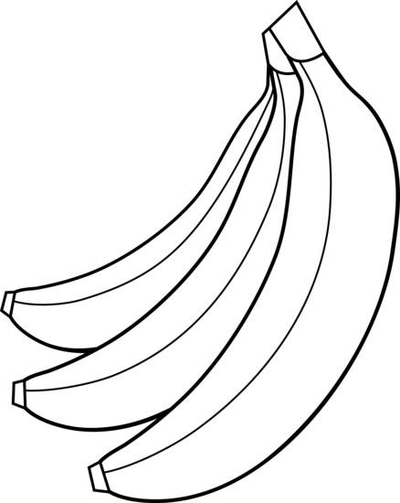

Circle what the teacher say: Multiple chocie
1. (1) 不可以(cannot) (2) 看书(read books) (3) 玩(play)

2. (1) 要不要(want or don’t want) (2) 好朋友(good friends)
(3) 跟我玩 (play with me)

3. (1) 走一走(walk) (2) 他(he) (3) 她(she)

4. (1) 老师(teacher) (2) 下课(recess) (3) 为什么(why)

Filling in the blank: 老师(teacher) 跟(with) 要(want)
- 我跟Peddle ___老师___一起吃饭。
I eat with Ms. Peddle.

- 我下课__跟__ 朋友们一起玩。
i play with friends during recess time.

- 你__要___吃水果吗？
Do you want to eat fruit?

Topic 14: shapes
Review: Topic 13, Time
o’clock 点钟 ____:30 ____点半
time 时间 parallelogram 平行四边形
square 正方形 trapezoid 梯形
rectangle 长方形 Circle 圆形
triangle 三角形
These vocabulary can be found on bloghttps://quizlet.com/98183656/flashcards

Math homework for spring break:
- Math 14-1, turn in 4/18.
- Math 14-2, turn in 4/19.
- Math 14-3, 14-5, turn in 4/20.
- Math 14-5, 14-7, turn in 4/21.

Chinese Recording assignment:

Topic: No recording assignment this week. But if you still have not done the last one, you can try to do it

Notes to Parents:
For the Chinese test, I really appreciate that you review it with your children! They did it so well! So, it will be great if we still go through the test with children to prepare the test. There are English for vocabulary and hope that helps! I really appreciate your time and support! Please let me know if you have any questions. Enjoy the weekend disappear9541@gmail.com Hsiaomei.tsai@canyonsdistrict.org

Science
The weather condition

This week the oral language topic:
Lesson: What are you wearing today?
https://quizlet.com/125224401/flashcards
Mandrain Matrix: I don’t want to go to school.
http://firstgradedi.weebly.com/mandarin-matrix.html

Reading:
High Frequency vocabulary 76-100: (Quizlet) https://quizlet.com/97609461/highfrequency-vocabulary-1st-grade-chinese-flash-cards/

Chinese Book: There is no book sent home anymore. But we watch the video on http://firstgradedi.weebly.com/chinese-baggy-book.html.
We read same book as last week:
1.Who has something to share?
(4/16-4/23)
http://firstgradedi.weebly.com/chinese-baggy-book.html

Chinese

Ms. Tsai

Math

