Chinese test 13 format and instructions. It will be tested on 4/14 (Thursday).

姓名：____________________ _______月 ________ 日 星期_______________
(I will help all students to do name and date)

Matching the pictures and characters
(I will read the characters to them and also no English when do the test.)

男(boy) 看(look,see) 老师(teacher) 红色(red) 黑色(black) 葡萄(grape)
土(dirt) 香蕉(banana) 要(want) 跟 (with…) 玩(play) 他(he) 她(she)

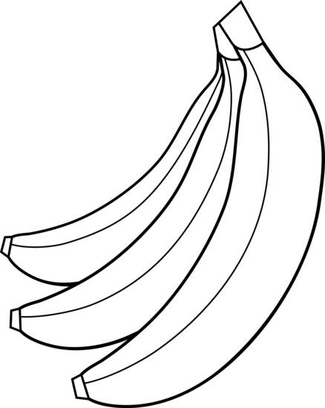
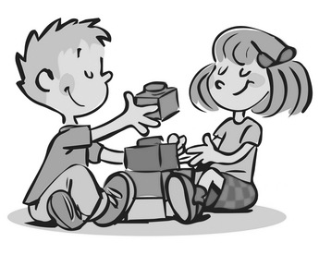
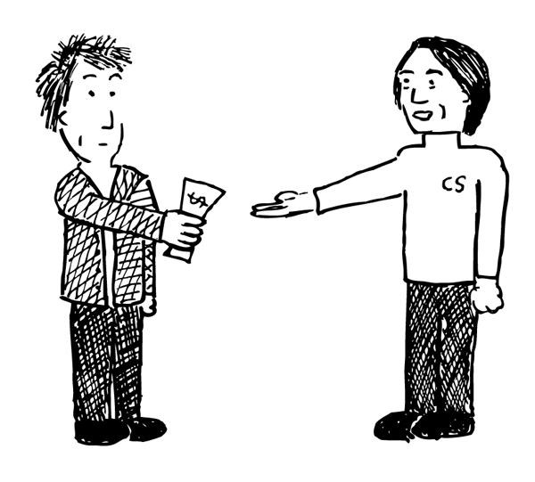
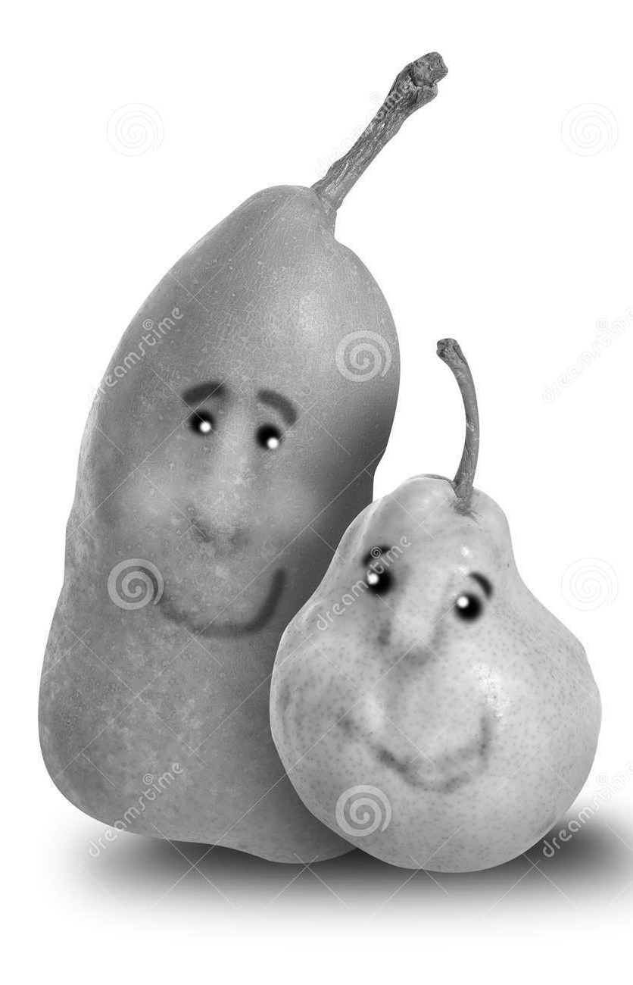

Circle what the teacher say: Multiple chocie
1. (1) 喜欢(like) (2) 看书(read books) (3) 玩(play)

2. (1) 不要(don’t want) (2) 朋友(friends) (3) 跟我玩 (play with me)

3. (1) 书(books) (2) 他(he) (3) 她(she)

4. (1) 老师(teacher) (2) 为什么(why) (3) 下课(recess)

Filling in the blank: 跟(with) 要(want) 老师(teacher)
- 我很喜欢Peddle ___老师___。
I lkie Ms. Peddle very much.

- 你__要___喝水吗？
Do you want to drink water?

- 我下课__跟__ 哥哥一起玩。
i play with my older brother during recess time

Notes to Parents:
For the Chinese test, I really appreciate that you review it with your children last time. They did it very well! So, this time, again, it will be great to go through the test with children to prepare the test. There are English for vocabulary and hope that helps! I really appreciate your time and support! Please let me know if you have any questions. Enjoy the Spring Break disappear9541@gmail.com Hsiaomei.tsai@canyonsdistrict.org

Science
The weather condition

Topic 13: Time
Review: Topic 12, Measurement: Length
o’clock 点钟 ____:30 ____点半
time 时间 borrow 借
left 剩下 long 长
short 短 tall 高
short hand 短针
These vocabulary can be found on bloghttps://quizlet.com/98183656/flashcards

Math homework for spring break:
It is a packet, so students turn in the whole packet on 4/11.

This week the oral language topic:
Lesson: What are you wearing today?
https://quizlet.com/125224401/flashcards
Mandrain Matrix: Whose birthday cake?
http://firstgradedi.weebly.com/mandarin-matrix.html

Reading:
High Frequency vocabulary 60-75: (Quizlet) https://quizlet.com/97609461/highfrequency-vocabulary-1st-grade-chinese-flash-cards/

Chinese Book: There is no book sent home anymore. But we watch the video on http://firstgradedi.weebly.com/chinese-baggy-book.html.
We read same book as last week:
1.I like to eat… (4/03-4/15)
http://firstgradedi.weebly.com/chinese-baggy-book.html

Chinese Recording assignment:

Topic: My Family and Fruit.
Due is on 4/03. Instruction is attached to email and VIDEO is on our blog.
http://firstgradedi.weebly.com/chinese-recording-assignments.html

Chinese

Ms. Tsai

Math

