Chinese test 12 format and instructions. It will be tested on 3/24 (Thursday).

姓名：____________________ _______月 ________ 日 星期_______________
(I will help all students to do name and date)

Matching the pictures and characters
(I will read the characters to them and also no English when do the test.)

男(boy) 女(girl) 雨(rain) 绿色(green) 蓝色(blue) 西瓜(watermelon) 土(dirt) 香蕉(banana) 要(want) 跟 (with…) 玩(play) 他(he) 她(she)

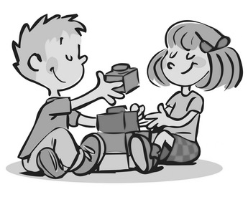

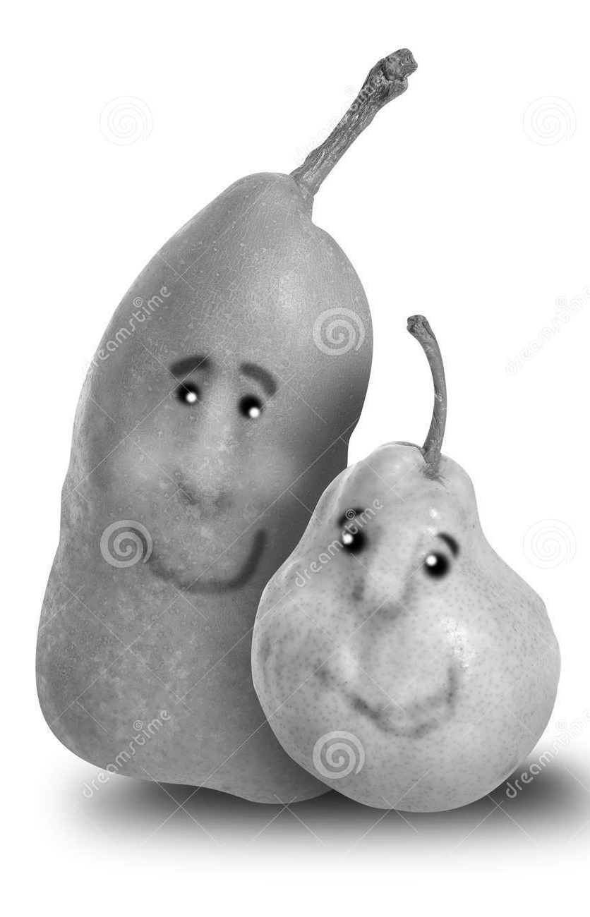
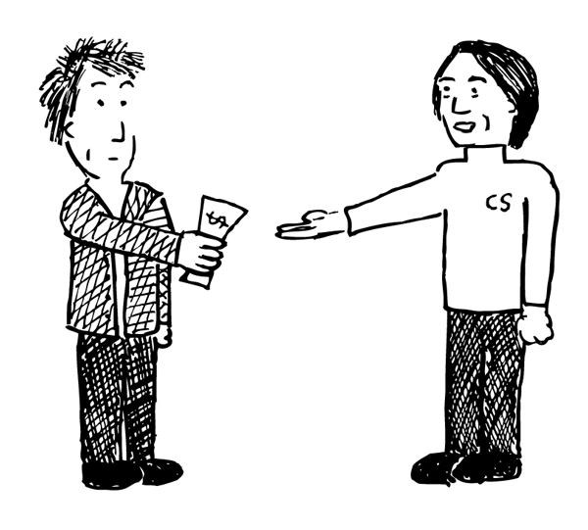

Circle what the teacher say: Multiple chocie
1. (1) 喜 (2) 欢 (3) 玩(play)

2. (1) 要(want) (2) 朋友(friends) (3) 跟(with)

3. (1) 玩(play) (2) 他(he) (3) 她(she)

4. (1) 很(very) (2) 绿色(green) (3) 蓝色(blue)

Filling in the blank: 跟(with) 要(want) 很(very)
- 我哥哥 __很__ 喜欢粉红色。
My older brother likes pink very much.

- 你要不要__跟___我玩？
Do you want to play with me?

- 我不__要__ 跟他玩。
i don’t want to play with him.

Topic 13: Time
Review: Topic 12, Measurement: Length
o’clock 点钟 ____:30 ____点半
time 时间 borrow 借
left 剩下 long 长
short 短 tall 高
These vocabulary can be found on bloghttps://quizlet.com/98183656/flashcards

Math homework:
- Math 12-6,13-1, Deadline: 3/28
- Math 13-2, 13-3, Deadline: 3/29
- Math 13-4, Deadline: 3/30
It is a packet, so students can turn in by dates or just a whole packet.

Science
The weather condition

This week the oral language topic:
Lesson: What are you wearing today?
https://quizlet.com/125224401/flashcards
Mandrain Matrix: Whose birthday cake?
http://firstgradedi.weebly.com/mandarin-matrix.html

Reading:
High Frequency vocabulary 60-75: (Quizlet) https://quizlet.com/97609461/highfrequency-vocabulary-1st-grade-chinese-flash-cards/

Chinese Book: There is no book sent home anymore. But we watch the video on http://firstgradedi.weebly.com/chinese-baggy-book.html.
We read same book as last week:
1.Play water (3/25-4/03)
http://firstgradedi.weebly.com/chinese-baggy-book.html

Chinese Recording assignment:

Topic: My Family and Fruit.
Due is on 4/03. Instruction is attached to email and VIDEO is on our blog.
http://firstgradedi.weebly.com/chinese-recording-assignments.html

Notes to Parents:
For the Chinese test, I really appreciate that you review it with your children last time. They did it well! So, this time, if possible, also going through the test with children to prepare the test. There are English for vocabulary and hope that helps you to understand those characters’ meanings. I believe if you review the test with your children, they will be good at this and lower their anxiety for the test. I understand it may be hard, so I really appreciate your time and support! Please let me know if you have any questions. disappear9541@gmail.com

Hsiaomei.tsai@canyonsdistrict.org

Chinese

Ms. Tsai

Math

