Chinese test 10 format and instructions. It will be tested on 3/24 (Thursday).

姓名：____________________ _______月 ________ 日 星期_______________
(I will help all students to do name and date)

Matching the pictures and characters
(I will read the characters to them and also no English when do the test.)

男(boy) 女(girl) 雨(rain) 苹果(apple) 橙(orange) 梨(pear) 草莓(strawberry) 西瓜(watermelon) 土(dirt) 香蕉(banana)

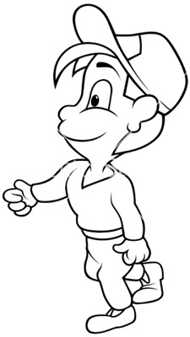
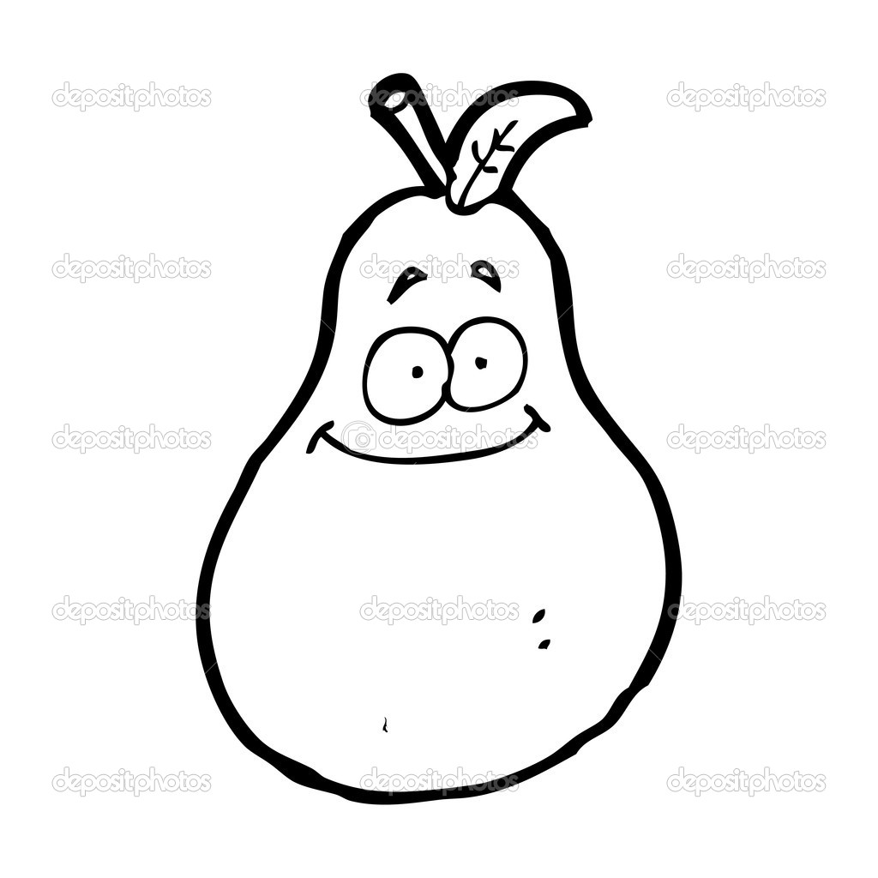

Circle what the teacher say: Multiple chocie
1. (1) 喜 (2) 欢 (3) 我

2. (1) 你(you) (2) 朋友(friends) (3) 小牛(cow)

3. (1) 吃(eat) (2) 好(good, okay, yes) (3) 们

4. (1) 很(very) (2) 玩(play) (3) 在(at)

Filling in the blank: 喜欢(like) 我们(we) 很(very)

- 妈妈 __很__ 喜欢吃苹果
Mom likes to eat appes very much.

- 我爸爸__喜_ __欢__绿色My dad likes green.

- _我__ __们__是好朋友。we are good friends.

Notes to Parents:
For the Chinese test, if possible, going through the matching part with children to prepare the test. There are English for vocabulary and hope that helps you to understand those characters’ meanings. I believe if you review the test with your children, they will be good at this and lower their anxiety for the test. I understand it may be hard, so I really appreciate your time and support! Please let me know if you have any questions.
Hsiaomei.tsai@canyonsdistrict.org

This week the oral language topic:
Lesson: What color do you like?
https://quizlet.com/125224401/flashcards
Mandrain Matrix: Plant flowers.
http://firstgradedi.weebly.com/mandarin-matrix.html

Reading:
High Frequency vocabulary 55-60: (Quizlet) https://quizlet.com/97609461/highfrequency-vocabulary-1st-grade-chinese-flash-cards/

Chinese Book: There is no book sent home anymore. But we watch the video on http://firstgradedi.weebly.com/chinese-baggy-book.html.
We read same book as last week:
1.Play sands (3/21-3/25)
http://firstgradedi.weebly.com/chinese-baggy-book.html

Social Study & Science
The life cycle of Frogs

Topic 13: Time
Review: Topic 12, Measurement: Length
o’clock 点钟 ____:30 ____点半
time 时间 borrow 借
left 剩下 long 长
short 短 tall 高
These vocabulary can be found on bloghttps://quizlet.com/98183656/flashcards

Character writing homework:
- Deadline: 3/21
- Deadline: 3/22
- Deadline: 3/23
- Deadline: 3/24
It is a packet, so students can turn in by dates or just a whole packet.

Chinese Recording assignment:

Topic: My Family and Fruit.
Due is on 2/29. Instruction is attached to email and VIDEO is on our blog. (I know it is past the deadline, but don’t worry about it, you can still submit it to me. Thank you!)
http://firstgradedi.weebly.com/chinese-recording-assignments.html

Chinese

Ms. Tsai

Math

